Saluda Hydroelectric Project (FERC Project No. 516) Relicensing Comprehensive Settlement Agreement
Draft – 6-03-2009

- Introduction

South Carolina Electric & Gas Company (SCE&G), as the holder of the current license for the Saluda Hydroelectric Project (Project)(FERC No. 516), hereby files the following Offer of Settlement Agreement pursuant to Rule 602 of the Rules of Practice and Procedure of the Federal Energy Regulatory Commission (“Commission”) 18 C.F.R. § 385.602 (2008). This Settlement Agreement has been entered into among SCE&G and Saluda Hydro Relicensing Stakeholders. Moreover, the parties to the Settlement Agreement request that the Commission incorporate the obligations and agreements as illustrated in Appendix A without material modification into the terms and conditions of the New License.

- Background

The Project is an existing licensed hydroelectric project located on the Saluda River, in the counties of Lexington, Richland, Newberry and Saluda, South Carolina. The Project consists of an earth fill embankment Dam (Saluda Dam) impounding a 48,000 acre reservoir (at elevation 356.5’), a gated emergency spillway, a combination rock-fill and RCC back-up Dam, a powerhouse, five concrete intake towers and associated penstocks. Construction of the Project was completed in 1930, and construction of the back-up dam was completed in 2005. The total rated generator capacity for the station is 207.3 MW. Further, at optimum gate openings, the hydraulic capacity of each of the Units 1 to 4 is 3,000 CFS, and for Unit No. 5 is 6,000 CFS, yielding a total station hydraulic capacity of 18,000 CFS.

The original fifty (50) year project license was issued by the Federal Power Commission in 1927, effective from August 4, 1927 to August 5, 1977. The currently effective license was issued by the Federal Energy Regulatory Commission (“FERC” or “Commission”) on June 1, 1984 retroactive to 1977, and was set to expire on August 31, 2007. SCE&G requested an extension of the term of the license by letter dated October 3, 2002 and the Commission issued an Order on November 18, 2003 extending the term of the license until August 31, 2010.

SCE&G officially began the formal relicensing process on April 29, 2005 by the timely filing of the Notice of Intent to the Commission and with the transmittal of its Initial Consultation Document (ICD) to resource agencies and other interested stakeholders for review and comment. Since that date, SCE&G has worked cooperatively with agencies and stakeholders through numerous resource group meetings to do the following: establish the scope of studies needed to address issues raised at the Project and develop study reports, conduct agreed upon studies, provide draft copies of study reports to agencies and stakeholders for review and comment, revise study reports to reflect agency/stakeholder comments, and complete follow-up studies deemed necessary to accomplish study goals. Resource group meetings have also served to provide a forum for discussion of Project related concerns among stakeholders. Discussions have continued to take place subsequent to the submittal of the License Application for the Project on August 27, 2008. These discussions among resource groups have been necessary to facilitate development of this Settlement Agreement and have culminated in the proposals set forth below. The Commission issued the Notice of Application Tendered for filing and solicited additional study requests on September 10, 2008.

- Purpose of the Settlement Agreement

The purpose of this Settlement Agreement is to define the consensus based resolutions formulated among the signatories of this Settlement Agreement to those issues that have been raised during the relicensing process for the Project. These resolutions set forth herein are respectfully proposed as terms for the New License and have been structured in accordance with the Federal Power Act Section 10(a)(1) for the balance of both developmental and non-developmental resources.

- Terms and Implementation

  - Terms

    - General

This Settlement Agreement is in no way intended to conflict with the legal responsibilities of the Settlement Agreement signatories, nor shall it be in conflict with any lawful statutory or regulatory responsibility of or authority held by said signatories. Furthermore, signatories to this Settlement Agreement are representing their belief that the issue resolutions developed through good faith efforts do not conflict with these responsibilities.

    - For the New License

The signatories to this Settlement Agreement recognize that the Commission will incorporate into the New License those articles pursuant to 18 C.F.R. 2.9 (“L-Forms”), as well as such articles as the Commission needs to carry out its responsibilities for administering and enforcing the New License. With these considerations, the signatories respectfully request that the Commission incorporate the terms set forth in this Settlement Agreement Appendix A into the terms of the New License without material modification. Based on the significant efforts made in the development of this comprehensive Settlement Agreement the signatories respectfully request that the Commission consider issuing a new license for a term of 50 years.

    - Fish Passage

A prescription for a fish passage facility pursuant to Section 18 of the Federal Power Act (FPA), 16 U.S.C. § 811, is not included in this Settlement Agreement. The reservation of authority of the Secretary of the Interior for the New License has been established by mutual agreement under the Santee River Basin Accord for Diadromous Fish Protection, Restoration, and Enhancement (Accord) (attached as Appendix A-5). The Accord was entered into among SCE&G, Duke Energy Carolinas, LLC, South Carolina Department of Natural Resources (SCDNR), North Carolina Wildlife Resources Commission (NCWRC), and United States Fish & Wildlife Service (USFWS). According to this agreement, the USFWS will file with the FERC its reservation of authority for any fishway prescriptions for the Project for the term of the new license. Although not a signatory to the Accord because of its position that it may not bind itself in any way that might infringe upon its statutory authority and obligations, the National Marine Fisheries Service (NMFS) and South Carolina Department of Health and Environmental Control (SCDHEC) were integral members of the team that developed the Accord, and will participate in its natural resource protection role as it determines appropriate.

    - Endangered Species Act:

Through cooperation, the signatories to this Settlement Agreement have developed a Rare, Threatened and Endangered Species (RT&E) Species Plan for the Project, which includes measures for the management of RT&E species in the Project Area. By the signing of this agreement, the USFWS and NMFS each represents that it believes the measures required by the Settlement Agreement will protect RT&E species and that it intends to issue a Biological Opinion (BO) consistent with such measures. This Settlement Agreement is in no way intended to compromise the authority of the USFWS and their determination of conditions for compliance with the Endangered Species Act (ESA), 7 U.S.C. §136; 16 U.S.C. §1531 et seq., or preclude any standard conditions pursuant to applicable law. In the event that a BO is issued that is inconsistent with this Settlement Agreement, with the exception of the above stated conditions, any signatory to this Settlement Agreement may withdraw after discussion as described in Section 4.b.

  - Implementation

    - Commitments of Parties

By the signing of this Settlement Agreement, signatories are expressing their support for the components herein (in some cases, as resolutions that may be less than they desire, but nevertheless representing compromise positions that they “can live with”), and the incorporation of these components into the new license issued by the Commission. Once the Settlement Agreement is signed, all signatories will support this Settlement Agreement in all public communications regarding the relicensing of the Saluda Hydroelectric Project.

Within 30 days after the draft National Environmental Policy Act (NEPA) document is issued, SCE&G will convene a meeting with the signatories to determine if the document is consistent with the terms of the Settlement Agreement. Should the NEPA document be inconsistent with the Settlement Agreement, the parties will work cooperatively to develop appropriate responses to address the inconsistencies.

SCE&G will convene a meeting within 14 days after the issuance of a new license to review the license conditions for consistency with the terms of the Settlement Agreement. Should the license be inconsistent with the Settlement Agreement, the parties will work cooperatively to develop appropriate responses to address the inconsistencies.

All signatories believe that this Settlement Agreement is consistent with all applicable laws and regulations. However, nothing in this Settlement Agreement is intended to abrogate the regulatory or statutory responsibilities of the parties under applicable law.

    - Commission Review of the Settlement Agreement

If the Commission has any questions or concerns with regards to the Settlement Agreement in the process of drafting the New License, it is requested that the Commission arrange for the convening of a technical conference to discuss these questions or concerns prior to the new license issuance.

    - Modification of the Settlement Agreement

After the signature period has ended, and prior to submission to the Commission, the signatories may by unanimous consent, modify the agreement.

In the event environmental analysis or other pre-license investigation yields material new information which may warrant changes to the Settlement Agreement, SCE&G will convene a meeting with the signatories to discuss whether and/or how to modify the Settlement Agreement to address the material new information.

After submission to the Commission, modification of Settlement Agreement can only occur by the unanimous consent of all signatories through negotiation meetings and written consent.

    - Legal Authorization of Signatories

By the signing of this Settlement Agreement each signatory is representing that they have the authorization by the party or parties they represent legally to bind that party or those parties to this Settlement Agreement. Moreover, upon signature, parties represented by the signing person(s) are legally bound to the terms expressed herein.

    - Withdrawal of Parties

A signatory may withdraw from this Settlement Agreement if their interests are materially affected by an Inconsistent Act by a Jurisdictional Body. An example of an Inconsistent Act could be if the new license requires flows and/or lake levels substantially different from those in the Settlement Agreement.

Any signatory intending to withdraw from this Settlement Agreement will notify all other signatories in writing of the basis for their withdrawal no less than 60 days prior to the withdrawal. With notice to all signatories, any other signatory may require a meeting of the withdrawing signatory to have the matter heard prior to withdrawal from the Settlement Agreement.

    - Termination of Settlement Agreement

Termination of this Settlement Agreement may occur under the following circumstances: (a) the withdrawal of SCE&G from this Settlement; Agreement (b) expiration of the New License term; (c) the termination or surrendering of the New License by SCE&G pursuant to the requirements of the FPA.

    - Signing Period

Once the Settlement Agreement is final, SCE&G will distribute the final document with a signature page to all relicensing Parties. Each Party will have a 30 day period in which to return a signed copy of the signature page to SCE&G.

    - Effective Date of Settlement Agreement:

This Settlement Agreement becomes binding on the signatories at the end of the 30 days signing period. With regards to the proposed terms for the license articles, as set forth in Appendix A, these terms only become effective upon their inclusion into the New License as issued by the Commission for the Project and are enforceable to the extent permissible by law.

    - Submittal of Settlement Agreement to the Commission:

This Settlement Agreement shall be submitted to the Commission as soon as reasonably possible, but no later than 60 days of the end of the signing period.

    - Structure of Settlement Agreement:

The preceding sections serve to establish the responsibilities of the signatories to this Settlement Agreement, the terms of which are defined in Appendix A. The signatories respectfully request that the terms of Appendix A be incorporated into the terms of the new license without material modification.

    - License Amendments

SCE&G will consult with signatories prior to requesting a license amendment that may be inconsistent with the Settlement Agreement.
DEFINITIONS:

The definitions set forth in the following sections are applicable to this Settlement Agreement and associated appendices and are fundamental to the understanding and interpretation of the material herein. When appropriate, these definitions may be adopted by the Commission into the articles of the New License.

- Acre-foot – A volume of water equal to one foot depth over an area of one acre, or 43,560 cubic feet.

- Benthic macroinvertebrates - Animals without backbones, which are visible to the eye and which live on, under, and around rocks and sediment on the bottoms of lakes, rivers, and streams.

- Cubic feet per second (CFS) - A measurement of water flow representing one cubic foot of water moving past a given point in one second. One CFS is equal to 0.0283 cubic meters per second and 0.646 million gallons per day..

- Cultural resources - Includes items, structures, etc. of historical, archaeological, or architectural significance.

- Dissolved oxygen (DO) - One of the most commonly employed measures of water quality, DO is the amount of gaseous oxygen in a liquid. Low DO levels can adversely affect fish and other aquatic life. The total absence of DO leads to the development of an anaerobic condition with the eventual development of odor and aesthetic issues.

- Drawdown - The intentional lowering of a reservoir for a defined purpose.

- Elevation - references in this Settlement Agreement are given in North American Vertical Datum 1988 (NAVD 88); conversion to traditional plant datum (PD, used in numerous supporting studies for the license application and frequently referred to as mean sea level (MSL)) requires the addition of 1.50 feet.

- Eutrophic - Water quality term that refers to undesirable conditions caused by the presence of high concentrations of nutrients, such as phosphorous and nitrogen. Eutrophication is the process of nutrient addition and/or concentration that drives water quality towards a higher eutrophic condition.

- Flow - The volume of water passing a given point per unit of time.

- Flow Forecasting Model – A computer based model developed by SCE&G to predict inflow to and operation of the Saluda Hydroelectric Project.

- Guide Curve – A series of target daily elevations for Lake Murray over the course of a year.

- Hydrologic Condition - The amount and distribution of precipitation, runoff, and streamflow in the Saluda River basin which affect the amount of inflow to Lake Murray at a given time

- Hypolimnetic – Related to the deeper cooler portions of a reservoir or lake that result from thermal stratification.

- Inconsistent Act – any action by a Jurisdictional Body that increases the burden upon or cost or risk to a Party substantially beyond the burden, cost, or risk assumed by the Party in this Settlement Agreement, or deprives a Party of a substantial benefit promised by another Party in this Settlement Agreement, such as by relieving another party of a substantial bargained-for obligation.

- Initial Consultation Document (ICD) - A document containing detailed information on a hydroelectric project; the document is used to describe the project and its resources and to start the applicant's consultation process with resource agencies and the public. It is in fact a collection of documents, taken together.

- Invasive Species - Species not native to the Project area and whose introduction is likely to cause detrimental effects to economic, environmental and/or human health.

- Jurisdictional Body – any governmental body which has the authority to prevent the implementation of, or to require specific steps be followed prior to implementing any part of this Settlement Agreement or to require activities that result in an Inconsistent Act.

- Lacustrine - Related to standing water, (e.g., a lake).

- Lake Elevation – The elevation of Lake Murray as measured by USGS gage number 02168500 located at the intake towers.

- Low Inflow Period - A hydrologic condition in the Saluda River basin draining to Lake Murray during which the 14 day average gauged inflow less estimated municipal usage (“net inflow”) falls below the scheduled Minimum Flow.

- Littoral - Associated with shallow (shoreline area) water (e.g., the littoral zone of an impoundment).

- Lotic - Flowing or actively moving water including rivers and streams.

- Minimum Flow – a continuous flow, measured in CFS, that is required to be released from the Project dam during a specified period of time

- Non-Governmental Organization (NGO) – An organization that has been created by an individual or group of individuals containing no membership or participation by any governmental entity.

- Non-Project Property – SCE&G lands not contained within the Project boundary.

- Non-Reserve Generation – Any generation other than reserve generation such as lake level management, recreation releases, swift water rescue training releases, minimum flow releases and striped bass flow release or any other releases not associated with reserve generation capability.

- Normal Inflow Periods - Any time when the Low Inflow Protocol is not in effect.

- Project - One or more hydroelectric plants collectively included in a single license issued by the FERC. Projects typically consist of a dam or dams, reservoir, powerhouse and appurtenant facilities. As used in this document, the capitalized term “Project” refers specifically to the Saluda Hydroelectric Project (P-516).

- Project area – All lands and water within and outside of the Project boundary that may influence or be influenced by Project operations.

- Project boundary or Project boundary line (PBL) - A demarcation line established by the FERC within which some level of interest in or control over all lands, waters and structures are deemed needed to operate a licensed hydroelectric project.

- Recreation area – A land and associated water surface area which people use for leisure activities, whether formally designated or used informally.

- Reserve Generation - That capability above firm system demand required to provide for regulation, load forecasting error, equipment forced and scheduled outages to SCE&G generating units, local area protection, to correct for or stabilize the system in the event of contingencies or to meet SCE&G’s VACAR reserve obligations as defined as Operating Reserve by the North American Electric Reliability Commission.

- Regulatory agency – A governmental agency that has statutory authority to regulate.

- Resource agency - Federal, state, or interstate agency with responsibilities for flood control, navigation, irrigation, recreation, fish or wildlife, water resource management, or cultural or other relevant resources of the state(s) in which a project is located.

- Stakeholder - Any individual or organization (government or non-governmental) with an interest in the management and/or operation of a hydroelectric project.

- Stratification - A physical and chemical process that results in the formation of distinct layers of water within a lake or reservoir (i.e., epilimnion, metalimnion, and hypolimnion).

- Streamflow - The rate at which water passes a given point in a stream, usually expressed in cubic feet per second (CFS).

- Tailrace - The tailrace is an area of stream downstream of a dam where the impounded water re-enters the river after passing through the turbines

- Wildlife Management Area (WMA) - An area established through the cooperative efforts of private landowners and the SCDNR to provide for the enjoyment of all wildlife enthusiasts. Seasonal hunting is allowed on these areas with the purchase of a WMA permit and hunting license.

Appendix A

Proposed Content of License Conditions

The following conditions outlined in this appendix serve to set forth the terms and conditions developed for the protection, mitigation, and enhancement of natural resources affected by the Project.

- SAFETY

Subsequent to the issuance of the new license, SCE&G shall:

  - Continue to adjust the existing warning system along the lower Saluda River in accordance with the Lower Saluda River Warning System Enhancement Plan (Appendix A-1).
  - Continue to maintain, modify as necessary, and operate an electronic ring-down call system (ERDS) for the life of the new license to provide notification to subscribers of flow releases from Saluda Hydroelectric Project even if the Safety and Outreach Program is modified, so long as the Safety RCG agrees that continued operation of the ERDS is appropriate and effective. The ERDS may be modified, terminated, or replaced with a newer or more effective technology or system upon agreement by the Safety RCG.
  - Continue to maintain, modify as necessary, and operate the SCE&G Lower Saluda River website for the life of the new license to provide notification of current operations and a schedule of planned operations for the Saluda Hydroelectric Project even if the Safety and Outreach Program is modified, so long as the Safety RCG agrees that continued operation of the Lower Saluda River website is appropriate and effective. The Lower Saluda River website may be modified, terminated, or replaced with a newer or more effective technology or system upon agreement by the Safety RCG.
- RECREATION

  - Recreation Plan:

Subsequent to the issuance of the new license by the Commission, SCE&G will implement the Saluda Hydroelectric Project Recreation Plan (Appendix A-2).

- FISH AND WILDLIFE

  - Lower Saluda River Aquatic Protection and Enhancement:

SCE&G shall implement the following enhancement programs for aquatic species in the LSR, developed in consultation with resource agencies, as part of this Settlement Agreement.

- Macroinvertebrate Surveys:

Subsequent to the issuance of the new license by the Commission, SCE&G will implement the Saluda Hydroelectric Project Lower Saluda River Benthic Macroinvertebrate Monitoring and Enhancement Program (Appendix A-3).

- Freshwater Mussel Research and Restoration:

Subsequent to the issuance of the new license by the Commission, SCE&G will implement the Saluda Hydroelectric Project Lower Saluda River Freshwater Mussel Restoration Program (Appendix A-4).

- Involvement in the Santee Basin Accord for Diadromous Fish Protection:

SCE&G shall continue to participate in and fund the Santee River Basin Accord for Diadromous Fish Protection, Restoration, and Enhancement (Appendix A-5).

- Sturgeon Management Programs:

Subsequent to the issuance of the new license by the Commission, SCE&G will implement the Saluda Hydroelectric Project Sturgeon Protection and Adaptive Management Program (Appendix A-6).

- Trout Adaptive Monitoring Program:

Subsequent to the issuance of the new license by the Commission, SCE&G will implement the Saluda Hydroelectric Project Trout Adaptive Monitoring Program (Appendix A-7).

SCE&G, resource and regulatory agencies and non-governmental organizations will evaluate and implement, where reasonable, opportunities to partner in enhancing efficiencies and effectiveness of activities tied to objectives set forth in the Trout Adaptive Monitoring Program.

Subject to the completion of the Trout Monitoring Program, SCE&G will consider potential partnerships with resource and regulatory agencies and non-governmental organizations for habitat enhancement projects in the lower Saluda River.

- Lower Saluda River Fish Community

SCE&G will continue to implement the annual fish community survey as described in Appendix A-8.

  - Rare, Threatened and Endangered Species Management Program:

Subsequent to the issuance of the new license by the Commission, SCE&G will implement the Saluda Hydroelectric Project RT&E Species Management Program (Appendix A-9).

  - Rare Plant and Animal Species of Interest Around Lake Murray and the Lower Saluda River Brochure:

Within 2 years after the issuance of the new license, SCE&G shall issue the Rare Plant and Animal Species of Interest Around Lake Murray and the Lower Saluda River Brochure. (Appendix A-10).

  - Fish Entrainment Mitigation Program:

Upon the issuance of the new license, SCE&G shall make official the fish mitigation program outlined below:

- In the event a turbine induced fish kill occurs that SCDNR determines necessitates a fish kill investigation, SCE&G will compensate the SCDNR for the lost fish and SCDNR staff time accrued during investigations, if SCE&G is found responsible for the fish kill.

Furthermore, SCE&G will employ the hydroacoustic equipment located near the intake tower number 5 in order to monitor fish movements and reduce the potential for fish entrainment and mortality during non-reserve call events. This equipment will be operational during the low DO months of July through October or such other period as determined by SCE&G in consultation with SCDNR when it is more likely that large numbers of fish will be congregated in front of Unit 5.

  - Purple Martin Roosting Area

SCE&G shall manage Lunch Island (Bomb Island) as a protected area for purple martin roosting.

  - Flow Releases to the Lower Saluda River:

Subsequent to the issuance of the new license by the Commission, SCE&G will implement the Saluda Hydroelectric Project Flow Release Program (Appendix A-11).

- WATER QUALITY

The lower Saluda River is classified as Trout Put, Grow and Take (TPGT) from the Lake Murray Dam to its confluence with the Broad River. As conditioned in its new license, SCE&G will do all it reasonably can to maintain and support the existing uses. Dissolved oxygen and temperature levels will be measured at the existing USGS gage (02168504).

  - The Upgrade of Unit Runners:

During the period of the new license issued by the Commission, SCE&G plans to install new runners of modern design that offer higher efficiencies, output, and dissolved oxygen (DO) uptake, and to rewind the generators according to the schedule discussed below.

While providing for enhanced unit efficiency and maintaining the reliability necessary to meet generation obligations, upgrading the existing unit runners will provide positive benefits for downstream DO levels such that 100% support of the South Carolina lower Saluda River site specific DO standard may be assured.

The complete schedule for runner upgrades will be determined based on an adaptive program. The adaptive program is intended to allow for a full evaluation of the levels to which downstream water quality goals are achieved as a result of improvements resulting from each unit upgrade. At the point at which the DO standard is consistently maintained through all operating scenarios, whether it occurs after the first unit upgrade, the second one, or the third one, the remaining unit upgrades (if any remain to be done) will be implemented in a purely economics-driven manner. This could extend the upgrade period to as long as 25 years after the issuance of the license. However, so long as environmental objectives are being achieved, an economics driven schedule for the remaining units is entirely justified.

The upgrade of Unit 5 will be completed within three years from issuance of the license. The upgrade of that unit is expected to take as long as three years to account for the need to accommodate the extensive design and testing necessary to assure the new runner meets the performance objectives. Subsequent to the Unit 5 upgrade, downstream water quality will be assessed, employing the adaptive management process. Subsequent unit upgrades may proceed thereafter as follows:

- Should it be necessary to upgrade another unit to assure support of the South Carolina lower Saluda River site specific DO standard, SCE&G will perform the upgrades on the following schedule:

  - Upgrade one of the smaller units (preferably Unit 3) within two years after the completion of the upgrade to Unit 5.

  - This process will be repeated with the sequential upgrades of Units 4, 1, and 2, each being achieved within two years after the completion of the previous unit upgrade should the effects of that prior upgrade not support the water quality goals. The sequence of unit upgrades as noted may change. SCE&G will determine the next unit for upgrades at the completion of the previous upgrade.

- Should the South Carolina lower Saluda River site specific DO standard be fully supported with installation of Unit 5 the SCE&G will perform the upgrades on the following schedule. Should reliability or other issues require the upgrade of one or more of the units sooner than proposed, the schedule will be accelerated to meet the identified need.
  - Unit 3 will be upgraded within five years after license issuance;
  - Two units (preferably Units 4 and 1) will be upgraded within 15 years of license issuance; and
  - The last unit (preferably Unit 2) will be upgraded within 25 years after license issuance.
Until these upgrades are complete, SCE&G agrees to continue with turbine aeration measures (i.e. turbine venting and hub baffles) and operational modifications implemented since 1999 and as conditioned by FERC Order 108 FERC ¶ 61,064.

  - Reservoir Drawdowns

Subsequent to the issuance of the new license by the Commission, SCE&G will implement the Saluda Hydroelectric Project Reservoir Drawdown Program (Appendix A-12).

  - Unit 5 Operation Subsequent to Unit Upgrades:

Upon completion of Unit 5 upgrades, approximated to be 3 years after the issuance of the new license, SCE&G shall operate Unit 5 in a “first on, last off” scenario during generation events in order to aid in preservation of a coolwater refuge habitat for the benefit of the reservoir fisheries. Minimum flows will be accomplished mainly with the bottom oriented units (Units 1 through 4). The operation scenario shall be as follows:

For generation flows (flows in excess of minimum flows):

- Unit 5 shall be operated preferentially as “first on, last off” from November 1 through July 31 of each year.

- The bottom-oriented units (Units 1 through 4) shall be operated preferentially as “first on, last off” during the months of August through October.

- OPERATIONS

  - Low Inflow Protocol and Operations during Maintenance Activities and Emergency Situations:

Subsequent to the issuance of the new license by the Commission, SCE&G will implement the Saluda Hydroelectric Project Maintenance, Emergency, and Low Inflow Protocol (Appendix A-13)

  - Lake Level Management:

Subsequent to the issuance of the new license by the Commission, SCE&G will implement the Saluda Hydroelectric Project Normal Reservoir Operating Guidelines (Appendix A-14)

- LAKE AND LAND MANAGEMENT

  - Implementation of Shoreline Management Plan and Lake Murray Shoreline Management Handbook and Permitting Guidelines:

Subsequent to the issuance of the new license by the Commission, SCE&G will implement the Saluda Hydroelectric Project Shoreline Management Plan (SMP) (Appendix A-15) as developed in consultation with the Lake and Land Management Technical Working Committee.

  - Lands Designated for the Enhancement of Waterfowl Habitats:

Subsequent to the issuance of the new license by the Commission, SCE&G will offer to lease approximately 1,100 acres of Forest Management land, as identified in Appendix A-16, to SCDNR to be placed/maintained in their WMA Program as DNR elects. The purpose of placing these lands in the WMA Program will be to enhance waterfowl habitat and provide public waterfowl hunting opportunities. The lease will be co-terminus with the new license issued by the Commission.

  - Aquatic Plant Management:

Subsequent to the issuance of the new license by the Commission, SCE&G shall work cooperatively with the SCDNR Aquatic Nuisance Species Program and the S.C. Aquatic Plant Management Council (Council) to manage invasive aquatic plants in Project waters for the term of the new license. SCE&G shall assist in the development of, abide by, and share with the funding of annual aquatic plant management plans approved by the Council.

- CULTURAL RESOURCES

  - Historic Properties Management Plan

Subsequent to the issuance of the new license by the Commission, SCE&G will implement the Saluda Hydroelectric Project Historic Properties Management Plan (Appendix A-17).

Appendix A-1
Lower Saluda River Warning System Enhancement Plan
APPENDIX A-1
Lower Saluda River Warning System Enhancement Plan

Lower Saluda River Warning System Installation:

Subsequent to the issuance of the new license, SCE&G shall continue with the installation of planned enhancements to the warning system along the lower Saluda River in accordance with the following schedule:

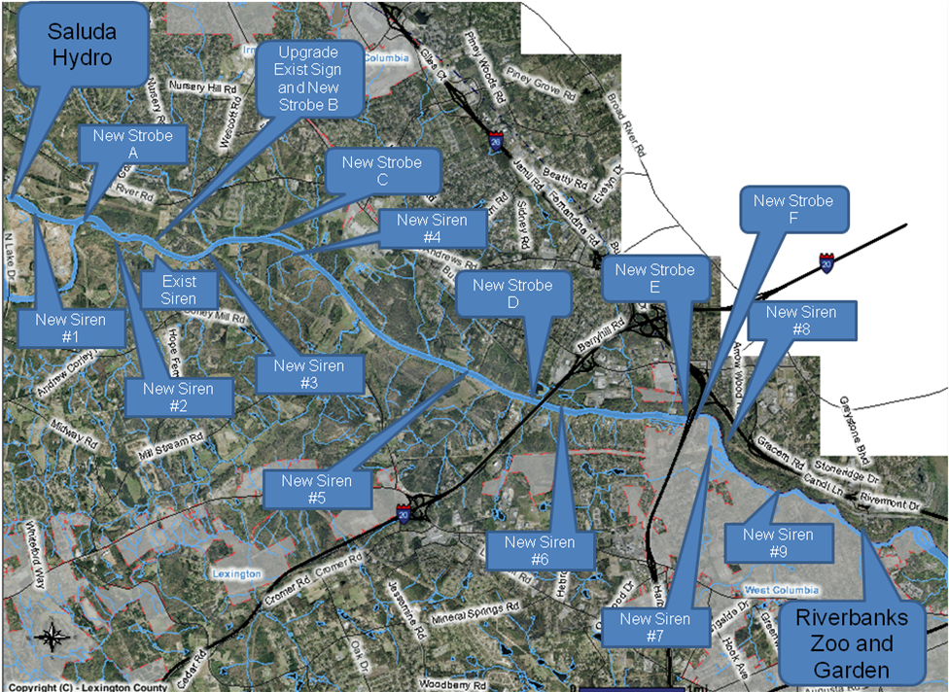

Phase 1 - new sirens #1 and #2, new strobe lights A and B, and upgrade of existing sign at Saluda Shoals Park – Complete – Installed and Operational as of 2008.

Phase 2 - new strobe lights C, D, E and F – To be installed within one year after issuance of the new license.

Phase 3 - new sirens #3, #4, #5, #6, #7, #8, and #9 – To be installed within two years after installation of Phase 2 is complete. If it is determined that a siren in Phase 3 is not needed or needs to be modified to a strobe, or if other issues arise that make the installation not feasible, then that siren will not be installed.

Appendix A-2
Saluda Hydroelectric Project Recreation Plan

Appendix A-2 is included as a separate PDF file on the webpage

Appendix A-3
Saluda Hydroelectric Project Lower Saluda River Benthic Macroinvertebrate Monitoring and Enhancement Program

Appendix A-3 is included as a separate PDF file on the webpage

Appendix A-4
Saluda Hydroelectric Project Lower Saluda River Freshwater Mussel Restoration Program

Appendix A-4 is still under discussion among the working committee

Appendix A-5
Santee River Basin Accord for Diadromous Fish Protection, Restoration, and Enhancement

Appendix A-5 is included as a separate PDF file on the webpage

Appendix A-6
Saluda Hydroelectric Project Sturgeon Protection and Adaptive Management Program

Appendix A-6 is included as a separate PDF file on the webpage

Appendix A-7
Saluda Hydroelectric Project Trout Adaptive Monitoring Program

Appendix A-7 is still under discussion among the working committee

Appendix A-8
Lower Saluda River Fish Community Surveys

Appendix A-8 is currently being developed by SCE&G

Appendix A-9
Saluda Hydroelectric Project RT&E Species Management Program

Appendix A-9 is included as a separate PDF file on the webpage

Appendix A-10
Rare Plant and Animal Species of Interest Around Lake Murray and the Lower Saluda River Brochure
RARE PLANT AND ANIMAL SPECIES OF INTEREST AROUND
LAKE MURRAY AND
THE LOWER SALUDA RIVER

Wildlife abounds within the ecosystems supported by Lake Murray and the lower Saluda River, and is indeed one of the drawing features to visitors and residents of the area. Among the plants and animals that inhabit the lake and river environments are a number of rare, legally protected, or otherwise exemplary species that require special attention. A major focus in managing the lake environment is maintaining the balance between the natural environment that supports these species and human activity and occupation.

SCE&G has developed this brochure to educate the residents and visitors of the Lake about the rare and unique plants and animals occupying the area. By understanding the life requirements and threats to these species, it is our hope that visitors and lake residents will adopt a sense of stewardship for these species and their habitats. Armed with information, such as required habitats and the timing of breeding and nesting behavior, visitors can tailor their activities to minimize disturbance to these species. The public is encouraged to learn and understand the relationships between the rare species and their habitat, and to assume personal responsibility for their conservation. Ultimately, with an informed and conscientious public, these species and their habitats at Lake Murray and lower Saluda River can endure into the future and continue to mark the area as a valued natural resource.

This brochure is also available on the SCE&G website at http://www.sceg.com/en/my-community/lake-murray/. Copies can also be picked up at recreational sites, marinas, and parks around Lake Murray.

Bald Eagle

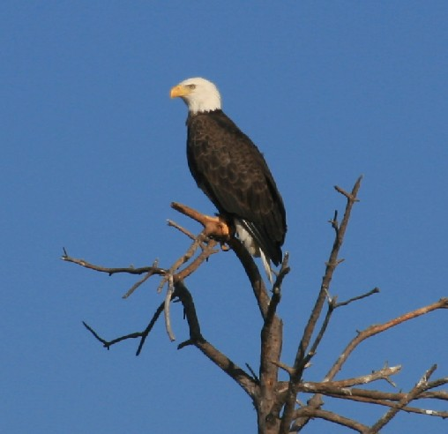
The bald eagle (Haliaeetus leucocephalus) is best known as the national bird of the United States of America. The bald eagle was previously listed as a federally endangered species due to population declines attributed to exposure to pesticides, loss of suitable habitat and illegal shooting. Today, the species has recovered to the degree that it was recently removed from the Federal Endangered Species List in July of 2007. The bald eagle continues to receive protection under the South Carolina Nongame and Endangered Species Conservation Act as a state endangered species, as well as federally through the Bald and Golden Eagle Protection Act and Migratory Bird Treaty Act.

The bald eagle is a bird of prey that may be found throughout North America, typically around water bodies, including Lake Murray and the lower Saluda River, where they feed and nest. Eagles forage on Lake Murray year round, with peak usage likely occurring during the winter months. Nesting of bald eagles on Lake Murray was first documented in 1996, and since that time, the nesting population has increased significantly. The South Carolina Department of Natural Resources (SCDNR) has recently documented seven active bald eagle nests on Lake Murray as well as one active nest on the lower Saluda River. Active bald eagle nests occurring within Lake Murray and lower Saluda River are managed by South Carolina Electric & Gas (SCE&G) in accordance with the National Bald Eagle Management Guidelines. These guidelines generally prohibit potential “disturbance” within 660 ft of an active nest during the nesting season (September through May) and 330 ft during the non-nesting season. Photo by Jennifer S. Hand

What You Can Do: Avoid disturbing eagles at nesting and feeding areas and provide habitat for eagles by maintaining mature trees on your property. If you find an injured eagle call the South Carolina Center for Birds of Prey at (843) 971-7474.
Wood Stork

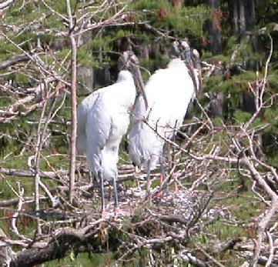
The wood stork (Mycteria americana) is a large wading bird native to coastal areas of South Carolina, Georgia, Florida and is the only stork species native to North America. The wood stork was federally listed as endangered in 1984, with population declines attributed primarily to loss of wetlands suitable for nesting and foraging. Like most other wading birds, wood storks feed primarily on small fish in habitats such as narrow tidal creeks, flooded tidal pools, freshwater marshes and freshwater wetlands. Wood storks typically use tall cypresses or other trees near wetlands or marshes for colonial nest sites. Nests are usually located in the upper branches of large trees and there are typically several nests in each tree. Currently, nesting of the species in the U.S. is thought to be limited to the coastal plain of South Carolina, Georgia and Florida.

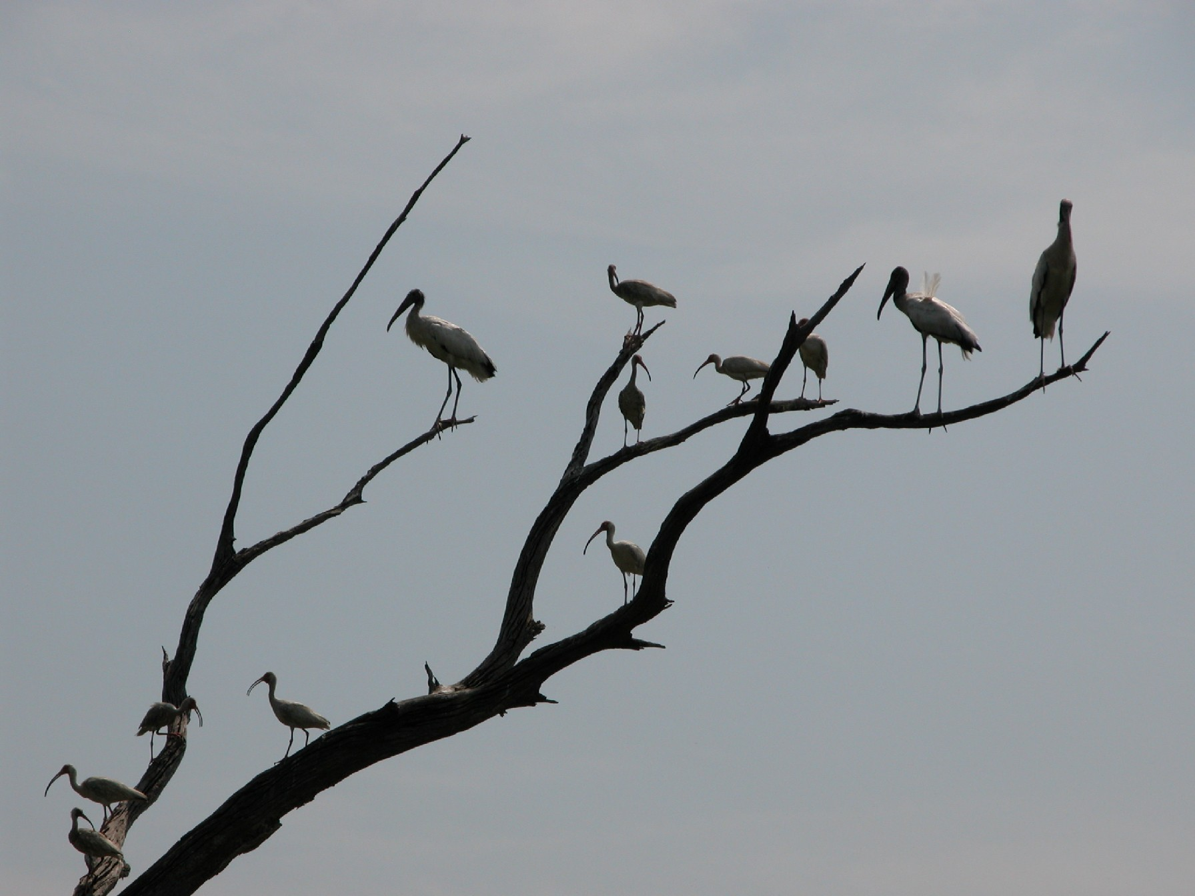
Wood storks were observed feeding at various locations in the upper portions of Lake Murray between the years of 2001 and 2006. A study conducted by SCE&G during 2005 and 2006, in cooperation with the SCDNR, found that a small number of wood storks periodically forage in the upper reaches of Lake Murray, the Saluda River upstream of the reservoir and nearby wetlands during the late-summer and early-fall of some years. Timing of these observations suggest that these wood storks are likely what is known by biologists as “post-dispersal migrations,” meaning that they likely nested or were hatched in coastal areas during the summer months, dispersed from the nest, and then migrating through the Lake Murray area to exploit temporary food sources (fish trapped in shallow pools) before returning to coastal areas for the winter.
Photos by Jennifer S. Hand
What You Can Do: If you happen to see a wood stork soaring above Lake Murray or wading along the shorelines call SCE&G’s Environmental Services at (803) 217-7132. Adult wood storks appear all white with long blackish-grey legs and pink feet. They have an unfeathered head and neck with a long, thick black bill. In flight, the wings underneath are edged in black.

Rocky Shoals Spider Lily

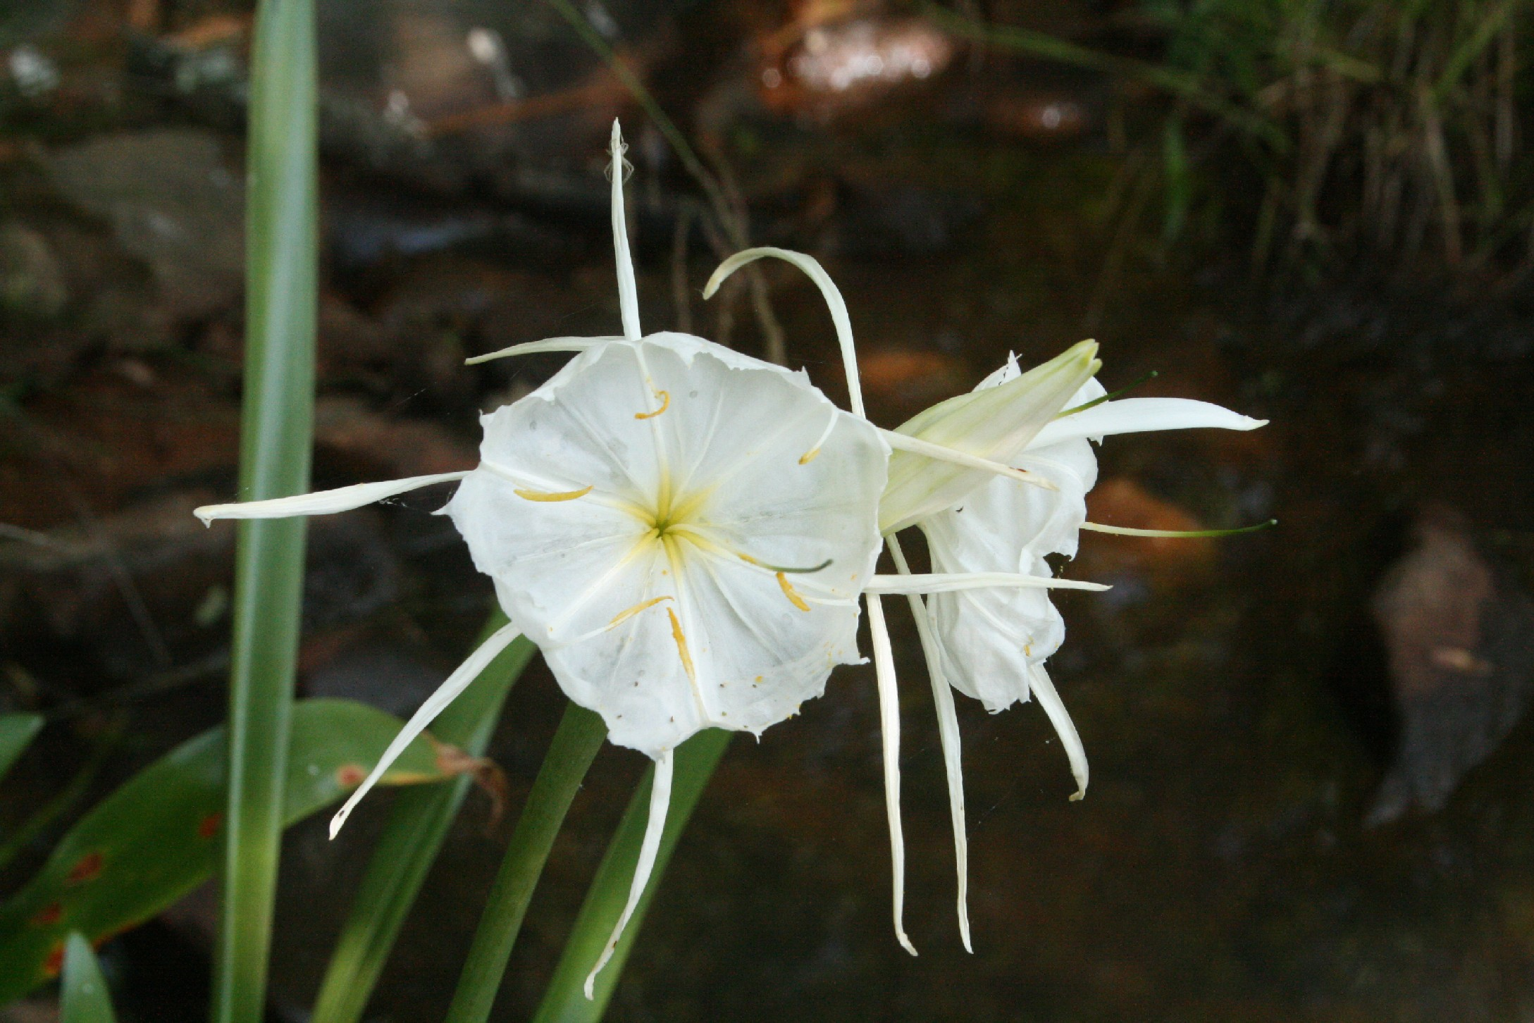
The rocky shoals spider lily (RSSL) (Hymenocallis coronaria), also referred to as Cahaba lily, is a flowering aquatic plant that typically inhabits large streams and rivers in South Carolina, Georgia and Alabama. As the name would suggest, these areas usually consist of rocky shoals hence and bedrock outcrops, which provide anchor points for the RSSL’s roots and bulbs. RSSL grows best in constantly flowing, shallow water. The decline of RSSL has historically been attributed to loss of shoal habitat due to construction of impoundments and other channel modifications. Threats to current populations include modification of river flows and fluctuating water levels resulting from dam operations, water pollution and collection for use in gardens. The RSSL is considered a species of concern by the State of South Carolina.

A good vantage point from which to observe the RSSL is at the Columbia Riverfront Park. The lily’s are in the island complex at the confluence of the Broad and Saluda rivers and just upstream of the confluence in the bypass reach of the Broad River downstream of the Columbia Diversion Dam. Each spring from mid-April to May in this section of the Broad River, one to three stalks will emerge from a RSSL bulb and each will produce a group of six to nine beautiful white flows. Photo by Jennifer S. Hand

What You Can Do: Do not pick the lilies or remove the bulbs for transplant, as they will not grow in a typical garden setting. Rocky shoals spider lilies are most beautiful in their natural habitat.

Shortnose Sturgeon

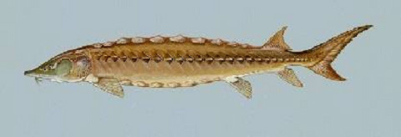
The Shortnose sturgeon (Acipenser brevirostrum) is one of the oldest living fish species, predating dinosaurs. They range from three to four feet in length and have primitive characteristics such as an elongated, slightly flattened body covered with bony plates (scutes). They have a toothless mouth that is positioned under the snout, which allows them to feed on bottom dwelling organisms. Shortnose sturgeon are spawned in freshwater rivers and migrate out to the ocean where they spend most of their life. Sturgeon will return to their natal rivers to spawn several times throughout their life. Shortnose sturgeon are restricted to the east coast of North America. The National Marine Fisheries Service has recognized South Carolina as one of the 19 distinct population segments of shortnose sturgeon. Shortnose sturgeon have been documented downstream of the dams associated with the Santee-Cooper Lakes (Marion and Moultrie) and as far up as the Congaree River in the vicinity of the Gervais Street Bridge. Photo by Duane Raver, USFWS

The shortnose sturgeon was federally listed as endangered on March 11, 1967, with population declines attributed to extensive overharvesting, loss of habitat, limited access to spawning grounds and polluted waters. Specific environmental conditions must be present for sturgeon to spawn such as specific water temperatures and available spawning habitat. Females will spawn every 3 to 5 years after reaching sexual maturity at age 8 to 12 years. With the combination of human threats along with the number of years it takes a female sturgeon to reach sexual maturity, it will take many years for the shortnose sturgeon populations to recover from its decline.

What You Can Do: Become familiar with the fish species native to your area before going fishing. If a live sturgeon is captured, return it safely to the water.

Purple Martin
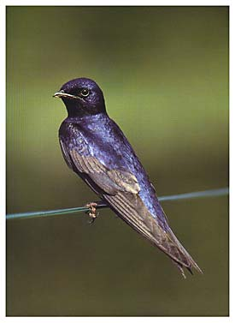
Purple martins (Progne subis) are the largest member of the swallow family in North America, measuring 7 1/2 inches long and weighing 1.9 ounces. An adult purple martin has long angular pointed wings, a large bill and forked tail. The male has a glossy blue-back, with duller black wings and tail. Female and juveniles are dusky black above, light beneath, with a smoke-gray throat and breast. Purple martins eat insects and airborne spiders, that are caught on their wings. Typically, purple martins prefer open countryside, but have also been seen in suburban areas where there are suitable nest sites.

The eastern and southern edge of Lunch Island (also known as Bomb Island) on Lake Murray, approximately 5 miles west of the Project dam, is one of the largest pre-migratory roosting sites for purple martins in the United States. The purple martin is a neotropical migrant, meaning that it migrates annually from its normal range in South America, the West Indies and portions of Central America, northward to breeding grounds across North America. This species is unique in that it nests in large colonies and is almost entirely dependant upon man-made structures for nesting. Following the fledging period, purple martins often congregate in large nocturnal roosts of 100,000 or more birds prior to returning southward. Beginning in late June and extending through August or early September these congregations engage in two mass movements daily as they exit the roost in the morning to feed and return in the evening. It has been estimated that at least 700,000 birds utilize the Lunch Island (Bomb Island) roost, prompting SCE&G, South Carolina Department of natural Resources and the Columbia Chapter of the National Audubon Society to enter into a Memorandum of Agreement to establish a cooperative arrangement for management of the habitat. SCE&G also registered the island with the South Carolina Audubon Society as an Important Bird Area in South Carolina.
Photo James R. Hill III - www.purplemartin.org

What You Can Do: The Purple Martin Conservation Association (PMCA) is a non-profit organization dedicated to the conservation of purple martins. PMCA is attempting to locate every active and inactive martin colony site in North America. If you have a purple martin colony site, or know someone who does, you can register your site at http://purplemartin.org/. So far, the organization has registered over 50,000 colony sites.

As part of a recent process to renew the Federal Energy Regulatory Commission (FERC) operating license for Lake Murray, SCE&G has committed to implementing a number of measures to enhance and protect habitat for rare wildlife and plants, as well as other species that inhabit the area. For example, under a new license, SCE&G will implement a Rare, Threatened and Endangered Species Management Program. This program includes measures to protect bald eagles nesting along Lake Murray and Saluda River shorelines, as well as monitoring and supplemental plantings of rocky shoals spider lilies at the confluence of the Broad and lower Saluda rivers. SCE&G will also impalement minimum flow releases to the lower Saluda River that will enhance fish habitat in the lower Saluda River downstream of Lake Murray dam, as well as habitat for striped bass and the federally-endangered shortnose sturgeon in the Congaree River. SCE&G has also proposed to implement a new “guide curve” for Lake Murray, which will result in the lake being at the normal maximum operating water surface elevation for a longer period of time during the year and provide for less dramatic winter drawdowns. The new guide curve will result in increased stability of fish habitat along shoreline areas.

The measures that will be implemented by SCE&G under a new FERC license for Saluda also have potential to enhance or protect habitat for a number of species identified in the South Carolina Department of Natural Resources’ Comprehensive Wildlife Conservation Strategy (CWCS). Although these species are not listed as threatened or endangered at the state or federal level, they are identified in the CWCS as being in need of conservation. Species identified in the CWCS as occurring in Richland, Lexington, Saluda and Newberry Counties, which surround Lake Murray, include:

Highest Conservation Concern | High Conservation Concern | Moderate Conservation Concern
Birds | Birds | Birds
American Coot | Acadian Flycatcher | Chestnut-sided Warbler
American Kestral | Bald Eagle | Common Loon
Black Duck | Black-throated Blue Warbler | Dark-eyed Junco
Black-throated Green Warbler | Blue-winged Teal | Golden-crowned Kinglet
Brown-headed Nuthatch | Forster's Tern | Great Blue Heron
Common Loon | Redhead | Great Egret
Eastern Meadowlark | Spotted Sandpiper | Greater Yellowlegs
Eastern Wood Peewee | Fish | Green Heron
Field Sparrow | Carolina Darter | Horned Grebe
Kentucky Warbler | Mussels | Louisiana Waterthrush
Lesser Scaup | Rayed Pink Fatmucket | Pectoral Sandpiper
Lesser Yellowlegs |  | Red-breasted Nuthatch
Little Blue Heron |  | Ringneck
Loggerhead Shrike |  | Scarlet Tanager
Mallard |  | Wood Duck
Painted Bunting |  | Fish
Pied-billed Grebe |  | Flat Bullhead
Prairie Warbler |  | Snail Bullhead
Solitary Sandpiper |  | Rosyface Chub
Swaison's Warbler |  | V-lip Redhorse
Western Sandpiper |  | White Catfish
Wood Stork |  | Mussels
Wood Thrush |  | Atlantic Spike
Fish |  | Carolina Lance
American Eel |  | Carolina Slabshell
Blueback Herring |  | Eastern Creekshell
Mussels |  | Variable Spike
Yellow Lampmussel
Savannah Liliput
Creeper

Additional information regarding the habits and biology of these species can be found in most nature field guides for the region and at the SCDNR website at http://www.dnr.sc.gov/cwcs/species.html.

Appendix A-11
Saluda Hydroelectric Project Flow Release Program
Appendix A-11
Flow Release Program

Flow Releases to the Lower Saluda River:

As a result of Instream Flow Incremental Methodology Study performed during relicensing at the direction of the Instream Flow Technical Working Committee (TWC) on the lower Saluda River (LSR), a Microsoft Access® database was created and used to calculate flow and the weighted usable area (WUA) relative percentage for each month for flow scenarios of interest to stakeholders. This in turn was used to test the success of various flow scenarios to maintain and enhance aquatic habitat. . After exploring a number of scenarios, the Licensee has agreed that it shall operate the Project in accordance with the following minimum flow schedule:

TIME PERIOD | FLOW (CFS) | PRIMARY BIOLOGICAL FUNCTION
Jan. 1 – Mar. 31 | 700 | Achieves habitat goals as outlined by the Instream Flow TWC based on a target minimum of 80% of the total available WUA
April 1 – May 10 | Striped Bass Enhancement Flow Regime (See below for details.) | Enhances striped bass spawning in the Congaree River and adult trout habitat in the lower Saluda River
May 11 – May 31 | 1,000 | Enhances adult trout and striped bass habitat
June 1 – Dec. 31 | 700 | Achieves habitat goals as outlined by the Instream Flow TWC based on a target minimum of 80% of the total available WUA

Striped Bass Enhancement Flow Regime

The Striped Bass Enhancement Flow Regime (STB Flows) were originally proposed by the South Carolina Department of Natural Resources (SCDNR) as a means of improving conditions for striped bass spawning in the Congaree River, which is formed by the confluence of the Broad and Saluda Rivers. It is SCDNR’s contention that conditions most favorable to striped bass spawning have historically occurred when flow in the Congaree River near the I-77 bridge was approximately 9,000 CFS during the April 1 through May 10 period. Favorable conditions are also thought to have occurred when the Saluda River contributes approximately 30 percent of the total flow in the Congaree River at Columbia. This corresponds to a flow in the Saluda River which would be approximately 45 percent of the flow in the Broad River as measured at the USGS Broad River at Alston, SC gage site (No. 02161000). The SCDNR developed a target flow regime for the Saluda Project designed to maintain a Saluda River 30% flow contribution to the Congaree River when flow in the Broad River at Alston is between 2,500 and 8,000 CFS during the April 1st – May 10th period each year. The STB target flow request is summarized as follows:

- April 1st – May 10th: Each day that the previous day’s daily average flow in the Broad River (measured at Alston gage) is between 2,500 CFS and 8,000 CFS, Saluda will release as a continuous target flow equal to the lesser of:
  - 45% of the previous day’s daily average flow in the Broad River at the Alston gage, or
  - The balance of what is required to create a 9,000 CFS in the Congaree River.
- The striped bass request flows are intended to be released continuously 24 hours per day and will be treated as target flows subject to a 1,000 CFS minimum flow to be released from Saluda Hydro when the previous day’s daily average flow in the Broad River (measured at Alston gage) is less than 2,500 CFS or greater than 8,000 CFS.

The STB target flow for a given day will be released to the extent possible as a continuous flow. It is recognized that STB habitat enhancement flows will vary on a day to day basis. For compliance purposes SCE&G will be granted a plus or minus 100 CFS variance of the STB target habitat enhancement flows. Determination of compliance shall be subject to matters beyond the reasonable control of SCE&G. The STB target flows will be determined on a daily basis using the previous day’s average flow in the Broad River measured at the Alston gage as shown in Table 1 and Chart 1. There will be no restriction on additional generation by Saluda Hydro if required during the STB flow period each year; when additional generation is no longer required on a given day, the STB target flow for the given day will be resumed. During the period from April 1 – May 10 when the previous day’s average flow in the Broad River at the Alston gage is less than 2,500 CFS or greater than 8,000 CFS, STB target flows will not be in effect and a continuous flow of 1,000 CFS will be released.

Exceptions to Prescribed Minimum Flow:

Because the Project is operated primarily and critically as a reserve facility, in the event of a reserve call, the Project outflows will likely increase above target minimum flows for short durations. In addition, recreational flow events, outlined in the Recreation Plan discussed in Section 2.2, will increase the referenced minimum flows for the duration of the events. In the event of a drought, minimum flows for the LSR will conform to the Maintenance, Emergency and Low Inflow Protocol (MELIP) outlined in Section 5.4.

Flow Releases to Enhance Striped Bass Habitat in the Congaree River Adaptive Management Plan:

The schedule for striped bass enhancement flow regime in this agreement is intended as a first attempt to reasonably meet the habitat needs in the Saluda and Congaree Rivers. In order to evaluate flow interests, an Adaptive Management Team (AMT) consisting of SCE&G, state and federal agencies, and other relicensing stakeholders with relevant experience and interests will be formed. Members of the AMT must be signatories to the settlement agreement. The AMT will meet annually, in February, to evaluate the results of the previous year’s striped bass flow period. In addition, the AMT may elect to meet as necessary during extreme, unforeseen weather events. The Instream Flow TWC will meet within one year after the settlement agreement is filed with the Commission. Among the items of business to be addressed at this meeting will be establishing qualifications of and terms for members of the AMT, and the creation of a charter and guidelines to operate under. The charter and guidelines shall at a minimum provide for the following items.

- Metrics: The AMT will set goals, develop parameters, including required measurements, develop study plans and reporting requirements prior to implementation of the striped bass flow regime.

- Monitoring Plan: The AMT will develop a monitoring plan within one year of license issuance that will identify the timing, frequency, and sampling methods associated with previously identified metrics. The monitoring plan will also include an evaluation of priority species in the LSR. The Licensee will not be responsible for any monitoring of this enhancement. All monitoring will be performed by State or federal agencies or other partners identified by the AMT. Funding may be provided by sources other than State and federal agencies.

- Decision Thresholds: During the 6th and 11th years, or such other years as determined appropriate by the AMT, following the issuance of the Saluda Hydroelectric Project new license, monitoring results will be assessed to determine if changes to the striped bass flows released from the Saluda Dam are needed. If the striped bass enhancement flow regime fails to meet goals identified by the AMT, an alternative operations or monitoring approach may be recommended and/or the flow will revert to the original recommendation of 1,000 CFS from April 1 to April 15, 1,300 CFS from April 16 to May 14 and 1,000 CFS from May 15 to May 31 or associated low inflow protocol flows. Any increase in flows from those specified above as the STB flows, must be agreed to by SCE&G before being implemented. SCE&G will consult with and consider other stakeholders interests who are signatories to the settlement agreement prior to agreeing to increased flows. Any continuation or reduction in flows from those specified above as the STB flows, must be agreed to by the AMT before being implemented.

- Reporting: The Licensee will file an annual progress report with the Commission on the efforts of the AMT by June 30.

Table 1Striped Bass (STB) Enhancement Target Flow Schedule
To be implemented annually April 1 – May 10
when Broad River daily average flow is between 2,500 and 8,000 CFS
Previous Day’s Average Flow in Broad River at USGS Alston Gauge (CFS) | STB Enhancement Target Discharge from Saluda Hydro (CFS) | STB Enhancement Allowable Discharge Range from Saluda Hydro (CFS)
<2,500 | 1,000 minimum | 1,000 minimum
2,500 – 2,999 | 1,300 | 1,200 – 1,400
3,000 – 3,499 | 1,500 | 1,400 – 1,600
3,500 – 3,999 | 1,700 | 1,600 – 1,800
4,000 – 4,499 | 1,900 | 1,800 – 2,000
4,500 – 4,999 | 2,100 | 2,000 – 2,200
5,000 – 5,499 | 2,300 | 2,200 – 2,400
5,500 – 5,999 | 2,500 | 2,400 – 2,600
6,000 – 6,499 | 2,700 | 2,600 – 2,800
6,500 – 6,999 | 2,300 | 2,200 – 2,400
7,000 – 7,499 | 1,900 | 1,800 – 2,000
7,500 – 7,999 | 1,500 | 1,400 – 1,600
≥8,000 | 1,000 minimum | 1,000 minimum

Footnote: This table was developed based on existing equipment and therefore is subject to change pending unit upgrades.

Chart 1

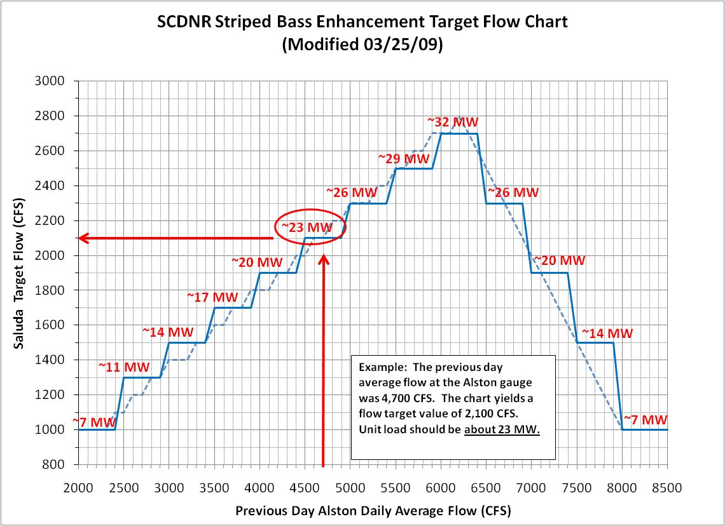

Appendix A-12
Saluda Hydroelectric Project Reservoir Drawdown Program
Appendix A-12
Reservoir Drawdown Program

SCE&G reserves the right to conduct periodic drawdowns for maintenance, inspections and safety issues as necessary. Additional drawdowns may be necessary for water quality , aquatic plant control and fisheries management.

It is the desire of all parties to maintain lake levels in Lake Murray as close to the guide curve as possible. However, SCE&G acknowledges that reservoir drawdowns can be an effective management tool to address problems with undesirable aquatic plants, fisheries management, and water quality; and periodic reservoir draw downs of Lake Murray may be utilized during the new license period as a management tool.

If an aquatic plant or fish population management problem is identified in Lake Murray , a meeting will be convened between SCE&G, appropriate resource agencies (DNR, FWS, DHEC) and interested stakeholders to develop a strategy to address the problem. Attempts should be made to reach a consensus based management decision. If it is agreed that any management activity is needed, SCE&G, in cooperation with the appropriate natural resource agency, will make a reasonable effort to publicly communicate the nature of the problem and the recommended management approach.

If water quality issues arise, a meeting will be convened between SCE&G, appropriate agencies and interested stakeholders to evaluate the need for a draw down, and make recommendations based on available information and data including potential impacts to other resources. Attempts should be made to reach a consensus based management decision. Recommendations for the frequency of drawdowns and a trigger are provided in the CE-QUAL-W2 water quality modeling report (see Attachment XX); however, using an average flow at the Chappell’s gage of 1,450 CFS or greater during the month of November. The lake may be drawn down for water quality to an elevation of approximately 350.0’ Plant Datum (348.5’ NAVD88). These recommendations will be in effect for a period of 12 years following the issuance of a new license. If conditions arise to cause concerns of potential water quality impacts, this plan will be re-evaluated. According to that report, failure to maintain the recommended drawdown schedule will increase the risk of poorer water quality (sediment accumulation, weeds, increased nutrient cycling from the sediments especially in embayments, and greater potential TMDL designation by DHEC that could lead to very expensive sediment treatments) compared to current conditions. Periodic winter drawdowns should be conducted to maintain dissolved oxygen required to meet State standards.

An Adaptive Management Team (AMT) consisting of SCE&G, state and federal agencies, and other relicensing stakeholders with relevant experience and interests will be formed. With the exception of DHEC, members of the AMT must be signatories to the Settlement Agreement. The AMT will meet in year seven of the new license to evaluate the effects of the drawdowns on water quality and aquatic resources within Lake Murray. In year thirteen the AMT will convene a meeting to evaluate the previous twelve year period to determine if modifications are necessary with respect to drawdowns in Lake Murray. Modifications that require actions that are beyond the scope of the new license will require a variance granted by FERC. An adhoc meeting may be convened at any time as conditions warrant.

During release of flows for a drawdown, consideration will be given to the effects on downstream resources.

Appendix A-13
Saluda Hydroelectric Project Maintenance, Emergency, and Low Inflow Protocol

PURPOSE

The Maintenance, Emergency, and Low Inflow Protocol (MELIP) for the Saluda Hydroelectric Project (FERC Project No. 516) is intended to provide operational guidance for abnormal operating situations caused by maintenance activities, emergency situations (including high inflow or flood events), and periods of sustained low inflow or drought conditions.

There are several types of maintenance activities which may require temporary modifications to normal reservoir levels and/or seasonal minimum flow and scheduled recreation flow releases. Certain emergency situations involving the interconnected electric system (“grid”), project structures, equipment, or waterways may also require temporary modifications to normal reservoir levels and/or seasonal minimum flow and scheduled recreation flow releases.

During periods of high inflow or flood events, the project must be operated to safely pass and/or store the high inflow without compromising the safety of the dam and other project structures. This may require temporary modifications to normal reservoir levels and/or seasonal minimum flow and scheduled recreation flow releases, either to pass higher than normal inflow, or to draw down the reservoir in advance of forecast high inflow.
During periods of low inflow, the Licensee’s goal is to conserve the remaining water stored in Lake Murray, in order to delay or prevent depletion of water stored in the reservoir. This will allow the project to continue to fulfill critical functions for as long as possible during drought periods: Reserve electric generation, municipal water supply, and preserve the recreational, environmental, and economic values of the Project waters.

TARGET RESERVOIR ELEVATIONS

Normal target reservoir elevations are defined by the Normal Reservoir Operating Guidelines. These are reservoir elevations which the Licensee will endeavor in good faith to achieve, unless operating under one of the conditions listed in this Maintenance, Emergency, and Low Inflow Protocol.

MINIMUM FLOW SCHEDULE

The seasonal minimum flow schedule is as follows (excluding low inflow conditions):

January 1 – March 31: 700 CFS
April 1 – May 10: Striped Bass Enhancement Flow Regime (See Appendix A-13-3 for details.)
May 11 – May 31: 1,000 CFS
June 1 – December 31: 700 CFS

It is agreed that a target flow of 500 CFS with a minimum flow of 400 CFS will be implemented during the MELIP.

OPERATION DURING MAINTENANCE ACTIVITIES

Under some maintenance conditions, it may be necessary to operate the project such that reservoir elevations and/or seasonal minimum or scheduled recreation flows cannot be maintained in the normal ranges, even during periods of normal inflow and hydrologic conditions. Examples of such conditions are:

- Scheduled or unscheduled project structure or hydro unit maintenance;
- Scheduled reservoir drawdown below normal minimum elevation due to required inspection or maintenance of project structures, ecological management of the lake (see Reservoir Drawdown Program), or improvements to lakeside facilities.
To the extent practical, the Licensee will avoid scheduling project structure or hydro unit maintenance that would impact the ability of the Licensee to release the required seasonal minimum flow or scheduled recreation flows, unless it is likely that further damage or unscheduled maintenance would ensue if the work is delayed. If it is determined that the seasonal minimum flows cannot be maintained due to the scheduled maintenance activities, the Licensee will consult with the resource and regulatory agencies (SCDNR, SCDHEC, USFWS, NMFS and any other appropriate resource agencies) to monitor and minimize impacts to water quality and aquatic habitat. To the extent practical, the licensee will also endeavor to replace any scheduled recreation flows which are impacted by the scheduled maintenance activities within the same calendar year as originally scheduled.

The reservoir may periodically be drawn down to its minimum level of el. 343.5’ (el. 345.0’ PD) for repairs to the upstream riprap armor on the original earth dam, inspection or repairs to the intake towers or spillway structure, or to accomplish other Project improvements. Scheduled drawdowns such as this would normally occur during October through February; however the time period may vary depending on the required scope of maintenance work. The Licensee will make public notification of scheduled drawdowns via media releases and announcements on the corporate web site as far in advance as practical and engage in appropriate public outreach such as education or seeking public input from interested stakeholders.

An unscheduled reservoir drawdown due to unforeseen equipment damage or other reason is very unlikely; however it is possible that this would occur at some time. To the extent practical, the Licensee will take steps to limit the magnitude and duration of any unscheduled reservoir drawdown.

OPERATION DURING EMERGENCIES

During emergency conditions, it may be necessary to operate the project such that reservoir elevations and/or seasonal minimum or scheduled recreation flows cannot be maintained in the normal ranges, even during periods of normal inflow and hydrologic conditions. Examples of such emergencies are:

- Grid voltage or capacity emergency declared by the Licensee’s System Operations Center or Transmission Operations Center;
- Dam safety emergency;
- Emergency plant shutdown due to equipment failure, fire, or other situations which endanger human health and safety or the environment;
- River access special circumstances (e.g., emergency rescue or recovery operations).
During a declared grid voltage or capacity emergency, the Licensee will operate the project as required to maintain or restore the reliability of the electrical system, with due regard to the safety of both the public and the project structures. This may result in deviation from scheduled recreation flows and/or normal reservoir operation levels.

During a dam safety emergency, the safety of the downstream population is paramount, and the Licensee will take actions as required to maintain or restore the integrity of all project water retaining structures. This may result in deviation from seasonal minimum flow, scheduled recreation flows and/or normal reservoir operation levels.

In the event of serious equipment failure, fire, releases or spills, or other conditions which endanger plant personnel, the public, or the environment, it may be necessary to completely shut down the Saluda Hydro plant and limit discharge from the facility to the minimum possible. This may result is deviation from seasonal minimum flow and/or scheduled recreation flows.

Upon request from local emergency response agencies, it may be necessary to decrease or increase the discharge from the Saluda Hydro plant in order to facilitate access to the lower Saluda River for rescue or recovery operations. This may result in deviation from seasonal minimum flow and/or scheduled recreation flows.

If it is determined that the seasonal minimum flows cannot be maintained due to an emergency condition, the Licensee will consult with the resource and regulatory agencies (SCDNR, SCDHEC, USFWS, NMFS and any other appropriate resource agencies) as soon as is practical to monitor and minimize impacts to water quality and aquatic habitat. To the extent practical, the licensee will also endeavor to replace any scheduled recreation flows which are impacted by the emergency situation within the same calendar year as originally scheduled.

OPERATION DURING HIGH INFLOW PERIODS OR FLOODS

The Licensee has developed a Flow Forecast Model (FFM) for the purpose of anticipating high inflow events due to large amounts of rainfall in the Saluda River basin draining to Lake Murray. The FFM uses precipitation forecasts from the National Weather Service (NWS) and near real time data from the U.S. Geological Survey (USGS) to estimate inflow to Lake Murray up to 5 days in advance. The Licensee’s System Operators also monitor the National Weather Service on a routine basis. In the event a weather system capable of producing heavy precipitation is forecast to impact the Saluda Project, the Licensee’s engineering staff runs the FFM using the latest precipitation forecast and current streamflow data from the USGS gauge network. Based on the magnitude and duration of the inflow hydrograph computed by the FFM, the System Operators are advised as to what action to take in order to safely pass and/or store the projected inflow. Such actions may include:

- Reduction of reservoir level below the existing target elevation in advance of or during the weather system to provide storage volume for the forecast inflow;
- Operation of one or more spillway gates to pass inflow in excess of that which can be passed by generation and prevent the reservoir from rising above el. 358.5’ (360.0’ PD);
- Allowing the reservoir to rise above the existing target elevation in order to store all or a portion of the inflow and limit excessive downstream releases.
Any of these actions may result in deviation from scheduled recreation flows and/or normal reservoir operation levels. To the extent practical, the licensee will endeavor to replace any scheduled recreation flows which are impacted by the high inflow conditions within the same calendar year as originally scheduled.

OPERATION DURING LOW INFLOW PERIODS

For operation during periods of sustained low inflow or drought, the MELIP defines trigger points and procedures for incremental reductions in seasonal minimum flow and downstream recreation flows based on gauged inflow to the project. During periods of normal inflow, the Licensee will operate the Saluda Project to maintain the reservoir level at or near the current target elevation within the proposed normal operating range of el. 352.5’ (354.0’ PD) to el. 356.5.0’ (358.0’ PD), while providing the normal seasonal minimum downstream flow and normal scheduled recreation and safety training flows. The project will be available for reserve generation as required by the Licensee’s system and obligations under the Virginia-Carolinas Electric Reliability Council (VACAR, or its successor) Reserve Sharing Agreement (VRSA). During times when inflow to the project exceeds the seasonal minimum flow and scheduled recreation flows, the project will generate on an as-needed basis to maintain the reservoir at or near the current target elevation.

If hydrologic conditions in the Saluda River basin draining to Lake Murray worsen and the 14 day average gauged inflow less estimated municipal usage (“net inflow”) falls below the scheduled minimum flow, water stored in Lake Murray will be used to augment project inflow to provide the normal seasonal minimum flow until the reservoir level falls to more than 1.0 ft. below the current target elevation. At that time, the Licensee will discharge target minimum flow as follows:

14 Day Average Net Inflow | Target Flow (except April 1st – May 10th)
< 1,000 CFS | 700 CFS minimum flow
< 700 CFS | 500 CFS target flow with 400 CFS minimum flow

If 14 day average net inflow falls below the scheduled minimum flow during the April 1st through May 10th period when the striped bass enhancement flow regime is in effect (as described in Appendix A-13: 3), reduced striped bass flows or continuous minimum flow will be implemented as follows, once the reservoir falls to more than 1.0 ft. below the current target elevation:

14 Day Average Net Inflow | Target Flow Provided April 1st – May 10th
< Striped Bass Flow Request (See Appendix A-13: 3 for Details) | 1,000 CFS minimum flow
< 1,000 CFS | 700 CFS minimum flow
< 700 CFS | 500 CFS target flow with 400 CFS minimum flow

If 14 day average net inflow should fall below the scheduled minimum flow between December 16th and January 17th, when the target reservoir elevation is within 1.0 ft. of el. 352.5’ (354.0’ PD), the reservoir will not be required to drop 1.0 ft. below the current target elevation before reducing the minimum flow. Additionally, at any time during a low inflow period (when 14 day average net inflow is less than the scheduled minimum flow), should the reservoir level fall below el. 352.5’ (354.0’ PD), the minimum flow from the project will be reduced to a target flow of 500 CFS (400 CFS minimum), and will remain at that value regardless of any increase of inflow until the reservoir level has risen above el. 352.5’ (354.0’ PD).

During periods where the inflow falls below the scheduled minimum flow and the reservoir level is below the target elevation range, SCE&G will make reasonable efforts to conserve the remaining water stored in Lake Murray to achieve its goal of allowing the lake level to reach the guide curve and re-establish normal minimum flows.

During an MELIP implementation, scheduled recreation flows will be reduced in two stages. First stage is when the reservoir falls more than 2 feet below target elevation or reaches 352.5’ (354.0’ PD) and the 14 day average net inflow is less than scheduled minimum flow; the recreation flow volume in acre-feet will be reduced by 30 percent. This can be accomplished either by reducing the flow or duration of a given event. Second stage begins once the reservoir level falls below el. 352.5’ (354.0’ PD); all scheduled recreation flows will be reduced to target minimum flow until the reservoir level has risen above el. 352.5’ (354.0’ PD). The 51 recreation days will remain protected from reserve operations during MELIP implementation.

During extended periods of low inflow, when depletion of the reservoir below el. 348.5’ (350.0’ PD) is imminent, the Licensee will consult with the South Carolina Department of Natural Resources (SCDNR), the South Carolina Department of Health and Environmental Control (SCDHEC), US Fish and Wildlife Service (USFWS) and other applicable resource agencies to determine if further reductions in minimum flow below 400 CFS should be considered. At that time, the Licensee will also coordinate a joint meeting with consulting agencies and the managers of the municipal water systems which withdraw water from Lake Murray, to determine a drought management plan that could include voluntary or mandatory water conservation measures, as determined by the agencies.

COORDINATION OF LOW INFLOW PROTOCOL WITH MAINTENANCE ACTIVITIES OR EMERGENCY CONDITIONS

If maintenance or emergency conditions require modifications to the normal reservoir target elevations and/or the normal minimum flow schedule during low inflow periods, the requirements of the maintenance activity or emergency condition may supersede the Low Inflow Protocol operation if necessary.

Drawdown of the reservoir due to maintenance or emergency conditions will not automatically trigger reductions in minimum flow, unless 14 day average inflow falls below the scheduled minimum flow. During refilling of the reservoir after a drawdown, if 14 day average inflow falls below the scheduled minimum flow while the reservoir is below el. 352.5’ (el. 354.0’ PD), the target flow will be reduced to 500 CFS (400 CFS minimum) until the reservoir exceeds el. 352.5’ (el. 354.0’ PD).

During periods of maintenance or emergency conditions if the reservoir elevation is below 352.5’ (el. 354.0’ PD), a meeting will be convened with the Recreational Advisory Flow Team (RAFT) to determine if recreation flow reductions are necessary in order to allow the reservoir to reach target levels.

It should also be noted that the South Carolina Department of Natural Resources (SCDNR) has certain statutory authority under the South Carolina Drought Response Act and Regulations, and nothing in this LIP is intended to abrogate that authority.
PERIODIC REVIEW OF PROTOCOL

The Licensee will consult with the South Carolina Department of Natural Resources (SCDNR), the South Carolina Department of Health and Environmental Control (SCDHEC), US Fish and Wildlife Service (USFWS), other applicable resource agencies and other relicensing stakeholders with relevant experience and interests that are signatories to the settlement agreement every 5 years during the license term to evaluate the effectiveness of the MELIP during the previous 5 years, and to determine if any modifications to the MELIP are required.

A-13: APPENDIX 2 – NET INFLOW COMPUTATION
INFLOW SCALING

The three USGS gauge stations used to compute inflow to Lake Murray are:

02167000 Saluda River at Chappells (gauged drainage area = 1,360 mi²)
02167450 Little River near Silverstreet (gauged drainage area = 230 mi²)
02167582 Bush River near Prosperity (gauged drainage area = 115 mi²)

Since the total drainage area of the Saluda River basin at the Saluda Dam is 2,420 mi², the discharge values recorded at the gauge sites must be scaled to provide an estimate of the total inflow to Lake Murray. The project drainage basin has been divided into seven sub-basins, five of which are downstream of Lake Greenwood and represent inflow to Lake Murray. Two sub-basins (nos. 6 & 7) are un-gauged, and inflow from these areas is estimated based on the Bush River gauge using the scale factors in the table below. [Note: a streamflow gauge was installed in 2008 on the Little Saluda River near Saluda (No. 02167705), however there has been insufficient flow for the USGS to calibrate (rate) the gauge since it was installed. When this gauge has been rated, it will replace the Bush River gauge for estimating flow from sub-basins 6 & 7.]

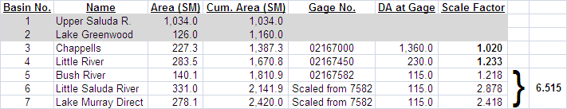

Using these scale factors, the total inflow (Q _{total}) to Lake Murray is computed as:

Q _{total} = (1.02)(Q _{Chappells}) + (1.233)(Q _{Little R.}) + (6.515)(Q _{Bush R.})

ESTIMATED MUNICIPAL WITHDRAWALS

Five municipal water intakes are permitted to withdraw water from Lake Murray. The total maximum withdrawal rate for these intakes is estimated to be approximately 120 CFS as of 2008. The actual withdrawal rate varies throughout the year, as estimated in the following table.

Month | Estimated Withdrawal Rate (CFS) | Month | Estimated Withdrawal Rate (CFS)
January | 60 | July | 120
February | 60 | August | 120
March | 60 | September | 120
April | 90 | October | 100
May | 100 | November | 60
June | 120 | December | 60

The above withdrawal rates are subtracted from the total inflow to Lake Murray to compute the net inflow to the project. The 14 day running average of net inflow is used to determine minimum flow during low inflow periods.

A-13: APPENDIX 3 – STRIPED BASS ENHANCEMENT FLOW REGIME
Striped Bass Enhancement Flow Regime

The Striped Bass Enhancement Flow Regime (STB Flows) was originally proposed by the South Carolina Department of Natural Resources (SCDNR) as a means of improving conditions for striped bass spawning in the Congaree River, which is formed by the confluence of the Broad and Saluda Rivers. It is SCDNR’s contention that conditions most favorable to striped bass spawning have historically occurred when flow in the Congaree River near the I-77 bridge was approximately 9,000 CFS during the April 1 through May 10 period. Favorable conditions are also thought to have occurred when the Saluda River contributes approximately 30 percent of the total flow in the Congaree River at Columbia. This corresponds to a flow in the Saluda River which would be approximately 45 percent of the flow in the Broad River as measured at the USGS Broad River at Alston, SC gage site (No. 02161000). The SCDNR developed a target flow regime for the Saluda Project designed to maintain a Saluda River 30% flow contribution to the Congaree River when flow in the Broad River at Alston is between 2,500 and 8,000 CFS during the April 1st – May 10th period each year. The STB target flow request is summarized as follows:

- April 1st – May 10th: Each day that the previous day’s daily average flow in the Broad River (measured at Alston gage) is between 2,500 CFS and 8,000 CFS, Saluda will release as a continuous target flow equal to the lesser of:
- 45% of the previous day’s daily average flow in the Broad River at the Alston gage, or
- The balance of what is required to create a 9,000 CFS flow in the Congaree River.
- The striped bass request flows are intended to be released continuously 24 hours per day and will be treated as target flows subject to a 1,000 CFS minimum flow to be released from Saluda Hydro when the previous day’s daily average flow in the Broad River (measured at Alston gage) is less than 2,500 CFS or greater than 8,000 CFS.

The STB target flow for a given day will be released to the extent possible as a continuous flow. It is recognized that STB habitat enhancement flows will vary on a day to day basis. For compliance purposes SCE&G will be granted a plus or minus 100 CFS variance of the STB target habitat enhancement flows. Determination of compliance shall be subject to matters beyond the reasonable control of SCE&G. The STB target flows will be determined on a daily basis using the previous day’s average flow in the Broad River measured at the Alston gage as shown in Table 1 and Chart 1. There will be no restriction on additional generation by Saluda Hydro if required during the STB flow period each year; when additional generation is no longer required on a given day, the STB target flow for the given day will be resumed. During the period from April 1 – May 10 when the previous day’s average flow in the Broad River at the Alston gage is less than 2,500 CFS or greater than 8,000 CFS, STB target flows will not be in effect and a continuous flow of 1,000 CFS will be released.

The chart on the following page was prepared to correlate the Broad River flow with the STB target flow request.

Striped Bass (STB) Enhancement Target Flow Schedule
To be implemented annually April 1 – May 10
when Broad River daily average flow is between 2,500 and 8,000 CFS
Previous Day’s Average Flow in Broad River at USGS Alston Gauge (CFS) | STB Enhancement Target Discharge from Saluda Hydro (CFS) | STB Enhancement Allowable Discharge Range from Saluda Hydro (CFS)
<2,500 | 1,000 minimum | 1,000 minimum
2,500 – 2,999 | 1,300 | 1,200 – 1,400
3,000 – 3,499 | 1,500 | 1,400 – 1,600
3,500 – 3,999 | 1,700 | 1,600 – 1,800
4,000 – 4,499 | 1,900 | 1,800 – 2,000
4,500 – 4,999 | 2,100 | 2,000 – 2,200
5,000 – 5,499 | 2,300 | 2,200 – 2,400
5,500 – 5,999 | 2,500 | 2,400 – 2,600
6,000 – 6,499 | 2,700 | 2,600 – 2,800
6,500 – 6,999 | 2,300 | 2,200 – 2,400
7,000 – 7,499 | 1,900 | 1,800 – 2,000
7,500 – 7,999 | 1,500 | 1,400 – 1,600
≥8,000 | 1,000 minimum | 1,000 minimum

Appendix A-14
Saluda Hydroelectric Project Normal Reservoir Operating Guidelines
Appendix A-14

Normal Reservoir Operating Guidelines

Lake Level Management:

Subsequent to the issuance of the new license by the Commission, SCE&G will employ the lake level management protocol discussed below and in the Maintenance Emergency and Low Inflow Protocol (MELIP) (Appendix A-13). This includes the implementation of the guide curve, developed in part with the objective of protecting the environmental, cultural, recreational and economic resources associated with and dependent upon the reservoir.

SCE&G agrees to operate Saluda Hydro to moderate lake level fluctuations, to address safety issues, improve recreation opportunities, and to support downstream flow targets, including striped bass flows. SCE&G agrees to make all reasonable efforts to operate during Normal Inflow Periods within a range of four feet, from a normal target operating lake level of 358’ Plant Datum (PD) between March 1 and August 31, and a lower operating limit of 354’ PD as illustrated in the lake level guide curve below. In order to maintain lake levels and minimize fluctuations,

SCE&G will operate in a manner that allows it to take advantage of surplus water for Non-Reserve Generation while making reasonable efforts to minimize downstream fluctuations in flow that may adversely affect habitat. This will ensure the Project is operated economically and aids in the protection of life and property, responds to changed hydrologic or other circumstances, meets lake management objectives, and does not interfere with required maintenance.

SCE&G shall, to the best of its ability and subject to the operational constraints, operate the Saluda Hydroelectric Project in a manner that follows the guide curve outlined below:

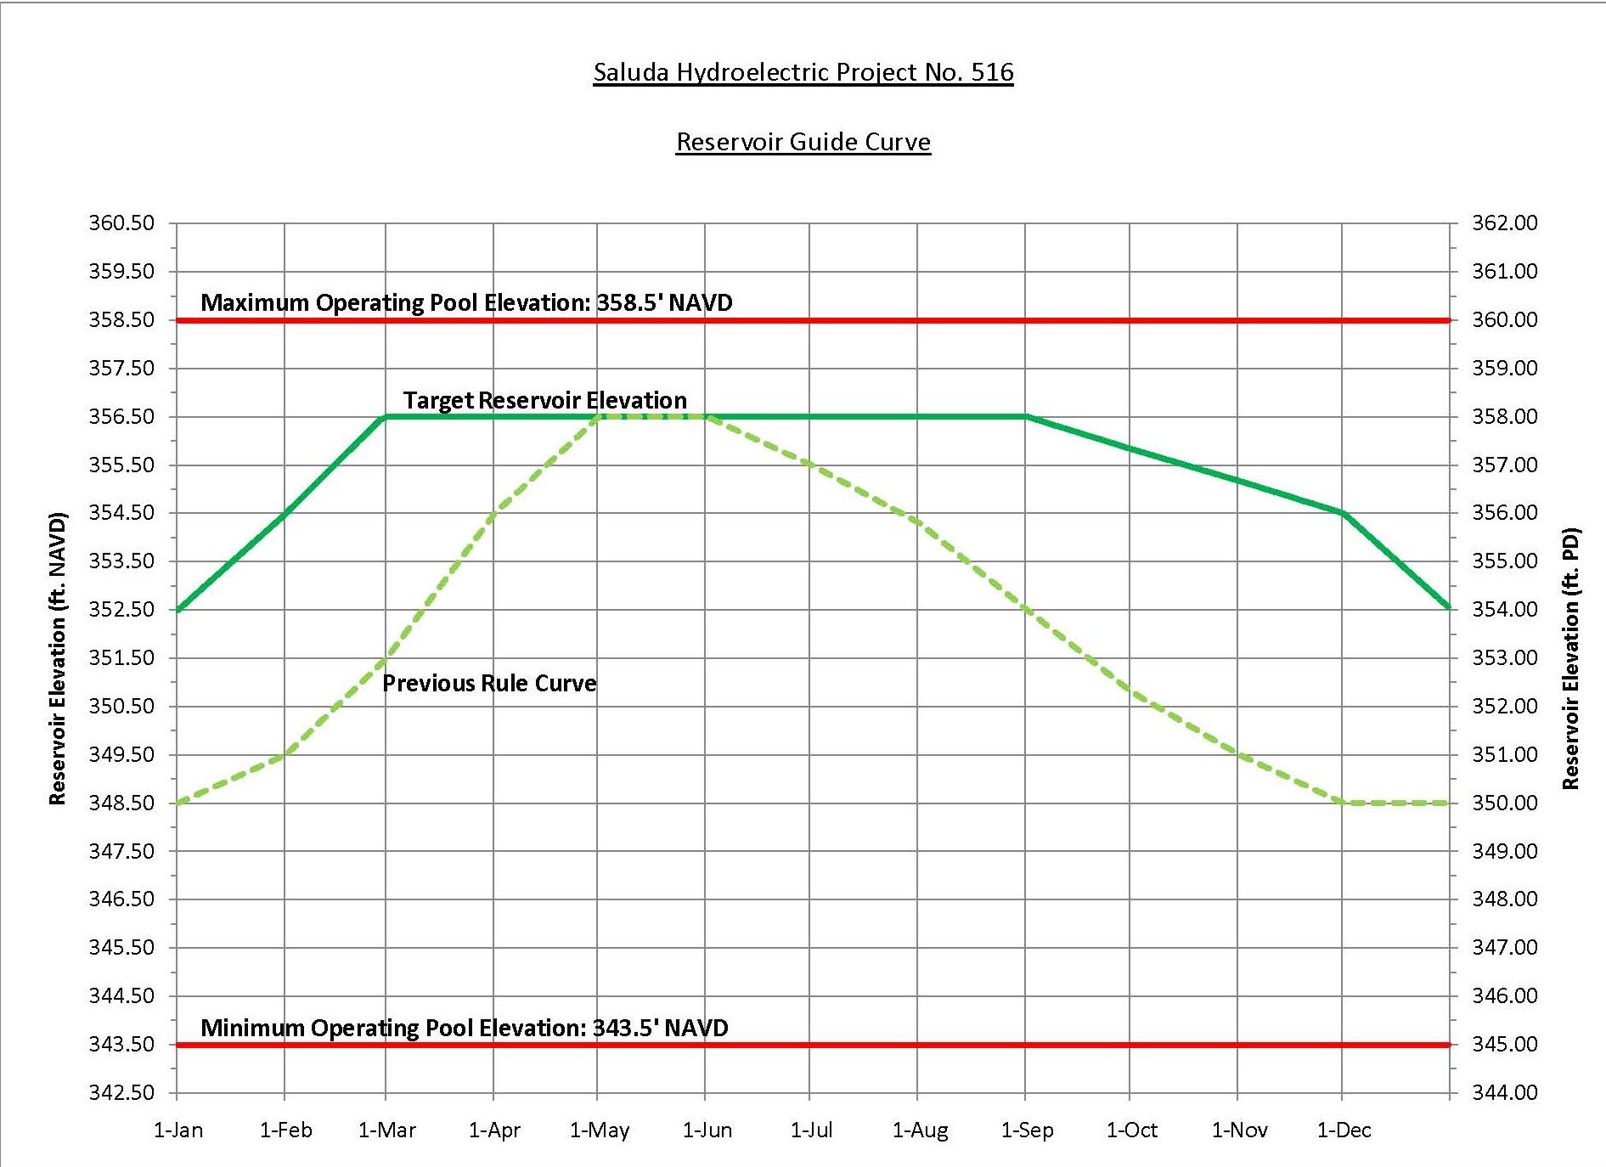

Reservoir Guide Curve Table – Elevations in Feet NAVD
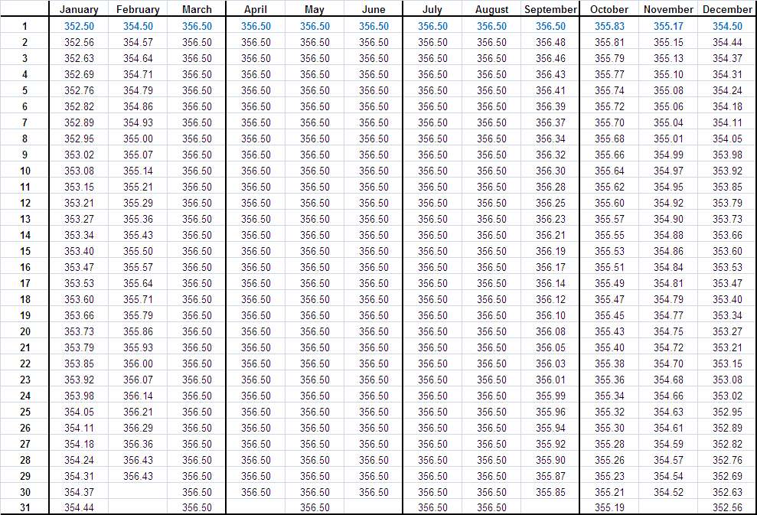

Reservoir Guide Curve Table – Elevations in Feet Plant Datum (PD)

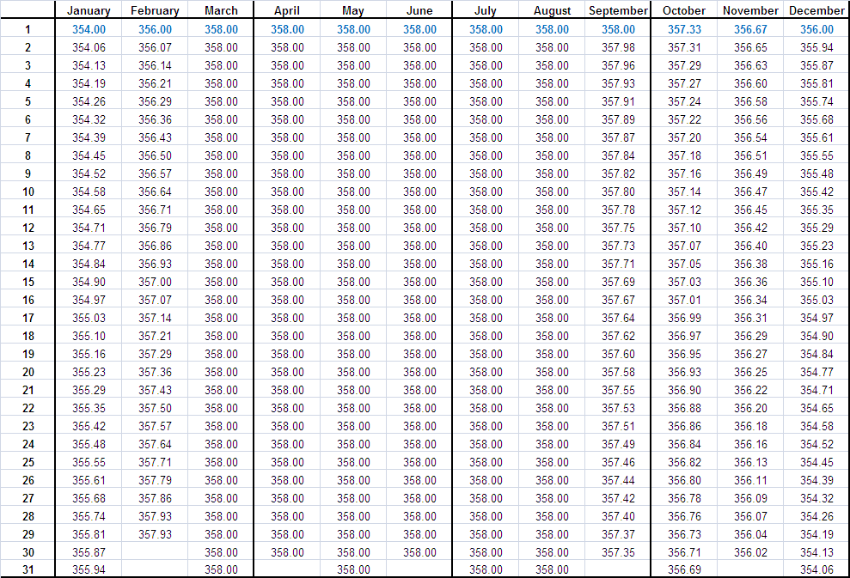

When SCE&G is not able to follow the guide curve due to low inflow to the reservoir, the MELIP shall be implemented.

Appendix A-15
Saluda Hydroelectric Project Shoreline Management Plan

Appendix A-15 is included as a separate PDF file on the webpage

Appendix A-16
Lands included in the SCDNR Wildlife Management Area Program to Enhance Waterfowl Habitat

Appendix A-16 is included as a separate PDF file on the webpage

Appendix A-17
Saluda Hydroelectric Project Historic Properties Management Plan

Due to the sensitive nature of the material contained within this report, the HPMP is not attached to the public version of this document.
Appendix B

Proposed Content of Off-License Agreements

1.0 Safety and Outreach Program

Administer as an off license agreement, the Safety and Outreach Program as developed in the context of relicensing. This will allow for the program to be modified by the Safety Resource Conservation Group (RCG) without requiring Commission approval. The Safety and Outreach program includes periodic meetings to review issues related to Project-related public safety. SCE&G shall maintain membership in the Safety RCG and provide a meeting location and administrative support a minimum of once per year so long as public interest remains high. Should meeting attendance at the annual meeting fall below three members (not including SCE&G and from at least three different, unrelated organizations), SCE&G’s obligation to provide an annual meeting location and administrative support shall cease, but SCE&G may nevertheless continue to participate in safety-related meetings with the public. A copy of the Safety and Outreach Program is attached as Appendix B-1.

2.0 Implementation of the Lake Murray Shoreline Management Handbook and Permitting Guidelines:

Subsequent to the issuance of the new license by the Commission, SCE&G will implement the Saluda Hydroelectric Project Lake Murray Shoreline Management Handbook and Permitting Guidelines (Appendix B-2) as developed in consultation with the Lake and Land Management Technical Working Committee.

3.0 Agreement to Lease Property to SCDNR for Inclusion in the WMA Program

Subsequent to the issuance of the new license by the Commission, SCE&G will offer to lease approximately 3,900 acres of property, as identified in Appendix B-3, to SCDNR to be placed/maintained in their WMA Program as DNR elects. The purpose of placing these lands in the WMA Program will be to conserve wildlife habitat, public hunting opportunities, and other compatible WMA uses. The leases will either be co-terminus with the new license issued by the Commission or on an annual basis as identified on Appendix B-3.

Waiver of WMA lease fees will be considered.

Appendix B-1
Saluda Hydroelectric Project Safety and Outreach Program

Appendix B-1 is included as a separate PDF file on the webpage

Appendix B-2
Lake Murray Shoreline Management Handbook and Permitting Guidelines

Appendix B-2 is included as a separate PDF file on the webpage

Appendix B-3
Lands included in the SCDNR Wildlife Management Area Program

Appendix B-3 is included as a separate PDF file on the webpage
Appendix C

Supporting Justification for the Settlement Agreement

Appendix D

Signatories to the Settlement Agreement

American Rivers: Signature: ___________________________ Date: _________
Rebecca R. Wodder,
President

American Whitewater: Signature: ___________________________ Date: _________
N. Charlene Coleman

Adventure Carolina: Signature: ___________________________ Date: _________
Richard B. Mikell

Capitol City/Lake Murray Country Tourism: Signature: ___________________________ Date: _________
Yet to be determined

City of Columbia Parks and Recreation: Signature: ___________________________ Date: _________
Yet to be determined

Coastal Conservation League: Signature: ___________________________ Date: _________
Dana Beach,
Executive Director

Eastern Band of Cherokee Indians: Signature: ___________________________ Date: _________
The Honorable Principal Chief Michell Hicks

Lake Murray Association: Signature: ___________________________ Date: _________
Yet to be determined

Lake Murray Docks, Inc.: Signature: ___________________________ Date: _________
James L. Leslie, Jr.
President

Lake Murray Homeowners Coalition: Signature: ___________________________ Date: _________
Yet to be determined

Lake Murray Power Squadron: Signature: ___________________________ Date: _________
Jeff Langlois
Commander

Lake Watch: Signature: ___________________________ Date: _________
Yet to be determined

Lexington County: Signature: ___________________________ Date: _________
Yet to be determined

Midlands Striper Club: Signature: ___________________________ Date: _________
B. Reed Bull, Jr.

National Park Service: Signature: ___________________________ Date: _________
Yet to be determined

NOAA, National Marine Fisheries Service, Southeast Region: Signature: ___________________________ Date: _________
Dr. Roy E. Crabtree
Regional Administrator

Newberry County: Signature: ___________________________ Date: _________
Yet to be determined

Saluda County: Signature: ___________________________ Date: _________
Yet to be determined

Saluda River Chapter of Trout Unlimited: Signature: ___________________________ Date: _________
Michael G. Waddell

South Carolina Council Trout Unlimited: Signature: ___________________________ Date: _________
Malcolm W. Leaphart Jr.
Relicensing Coordinator

South Carolina Department of Archives and History: Signature: ___________________________ Date: _________
Elizabeth M. Johnson
Deputy State Historic Preservation Officer

South Carolina Department of Natural Resources: Signature: ___________________________ Date: _________
John E. Frampton,
Director

South Carolina Department of Parks, Recreation and Tourism: Signature: ___________________________ Date: _________
Yet to be determined

South Carolina Electric & Gas Company: Signature: ___________________________ Date: _________
James M. Landreth
Vice President – Fossil & Hydro Operations

South Carolina Wildlife Federation: Signature: ___________________________ Date: _________
Yet to be determined

U.S. Fish and Wildlife Service: Signature: ___________________________ Date: _________
Yet to be determined

Unless otherwise noted, all elevation references in this Settlement Agreement and associated appendices are given in North American Vertical Datum 1988 (NAVD 88); conversion to traditional plant datum (PD, used in numerous supporting studies and often erroneously referred to as msl) requires the addition of 1.50 feet.
The currently effective license gives the station capacity as 202.6 MW. This value was based on a power factor of 0.8 for the original four generators. When Unit 3 generator was rewound, its power factor changed to 0.9, and this change was not taken into account in the application for the current license.
All elevation references in this MELIP are given in North American Vertical Datum 1988 (NAVD 88); conversion to traditional plant datum (PD, used in numerous supporting studies for this license application and often erroneously referred to as MSL) requires the addition of 1.5 ft.
Gauged inflow will be computed each day as the sum of three scaled USGS gauge values for the Saluda River, Little River, and Bush River, less estimated municipal usage from the reservoir. The 14 day average of these daily values will be computed each day. See Appendix 2 for details of inflow scaling and computing net inflow.
The existing municipal water intakes are approved for higher withdrawal rates than those shown in the table, which represent estimates of actual withdrawals as of 2008. If water withdrawal rates change or new intakes are approved, the Licensee may modify the estimated withdrawal rates used to compute net inflow.

